* SAP HR - Introduction
* SAP HR - Maintaining Relationships
* SAP HR - Time Constraints
* SAP HR - Maintaining Infotypes

The key modules are as follows −

* **Organizational Management** − Organizational Management includes Personnel development, Personnel cost planning and event management.
* **Time Management** − Time management includes time recording, attendance, time schedule, shift management, etc.
* **Personnel Administration** − Personnel Administration includes personal and organizational structure, Infotypes, integration with time and payroll, etc.
* **Payroll** − Payroll deals with payroll types, payroll group configuration, primary and secondary wages, gross pay, bonus, etc.
* **Recruitment** − Recruitment includes hiring an employee, maintaining HR master data, etc.
* **Training and Event Management** − Training and Event Management deals with identifying training needs, scheduling training, training cost management, etc.
* **Travel Management** − Travel Management includes managing official trips, cost management for travel, travel expenses, etc.

Organization Management

Organization Management allows you to manage the enterprise structure and analyze organization plans.

The key features are −

* In organization management, you can configure system settings that is required for enterprise structure, personnel cost planning, etc.
* You can define plan version to configure various organization plans at the same time.
* Only one plan version defines your organizational current plan.
* You can edit, change or compare different organization plans using plan version.
* You can have two different plan versions, one for marketing and other one for sales hierarchy.
* You can compare or edit both the plans but only one plan can be used at a time.

How to set a Plan version as active?

There are two ways to set a plan version.

**Step 1** − Use the code **T-Code: OOPV**

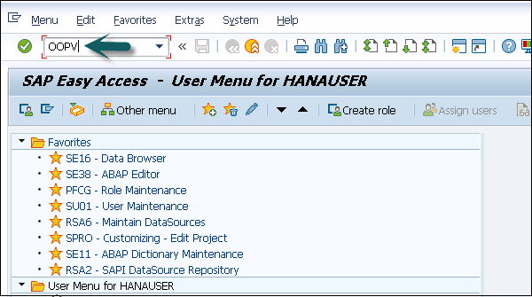

**Step 2** − Go to IMG → Personnel Management → Global Settings → Plan Version Maintenance → Maintain Plan Versions.

You can select from the list of available plans.

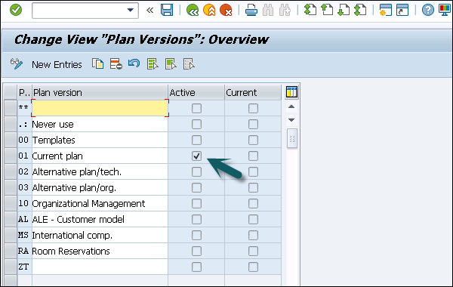

Organizational Object Types

An Organization plan consists of various object types, which define the grouping of similar data together. Each object type consists of a unique object key. All object types are linked together with a relationship among each other.

**Example** − A person holding a position that is defined by a specific job.

Relationship

In an Organization plan, relationships are used to link different object types.

**Example** − A person holding a position in an organization and is assigned with cost center. It defines Person to position relationship and position to Organization unit.

While defining an hierarchical organization structure, you are creating a relationship between organization objects. When a person is holding a position in an organization unit, it means there is relationship between the position object and the organization object.

Validity

It determines the life of object types. At the time of object creation, you enter the start and the end time of the project and this determines the validity of the object.

There are various types of object types that can be defined in an organization plan. Given below are most common object types and their keys −

|  |  |
| --- | --- |
| **Object Type** | **Key** |
| Organizational Unit | O |
| Person | P |
| Cost Center | K |
| Position | S |
| Job | C |

Key Features of Organization Objects

The key features are −

* You can create or change an existing object types, which are not managed.

**Example** − Object type person from HR Master Data.

* You can also define the relationship between different object types that should be proposed in the course of the authorization check.
* It is also possible to define an object type hierarchy to generate reporting.
* It is also possible to change the key of standard objects type- "S" for Position, "T" for task.

There are two types of Relationships −

* Relationships with the same object types.
* Relationships with different object types.

Number Ranges

You can maintain different number ranges for Organization Management and Personnel administration in SAP HR. As discussed in previous topic, OM contains different object types.

|  |  |
| --- | --- |
| **Object Type** | **Key** |
| Organizational Unit | O |
| Person | P |
| Cost Center | K |
| Position | S |
| Job | C |

To maintain the different number ranges for OM objects, you can use **T-Code: OONR**.

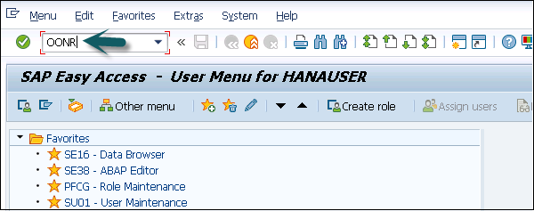

You can also choose the following path.

Go to IMG → Personnel management → Organizational management → Basic settings → Maintain number ranges → set up number assignment for all plan versions → Execute.

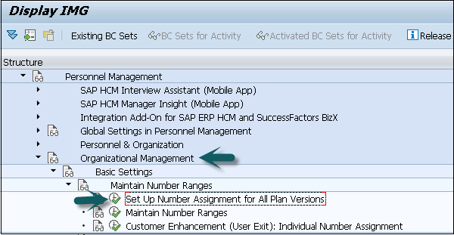

The first two digits represent your plan version and the next two letters represent the object type.

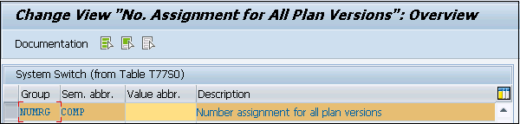

Similarly, you can maintain number ranges for personnel numbers. A Personnel number is generated when an employee is hired. It can be generated internally or externally.

The personnel number range whether internal or external should be defined at the following configuration node.

**Step 1** − **Use T-code: PA04**

**Step 2** − You can also go to SPRO → IMG → Personnel management → Personnel Administration → Basic settings → Maintain number range intervals for personnel numbers.

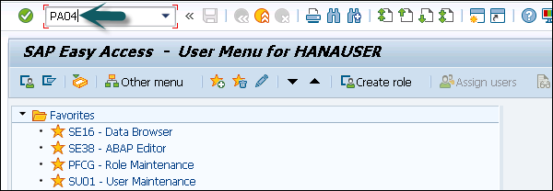

**Step 3** − A new window opens. You will see **Range Maintenance: Human resources**. Go to Intervals to display intervals.

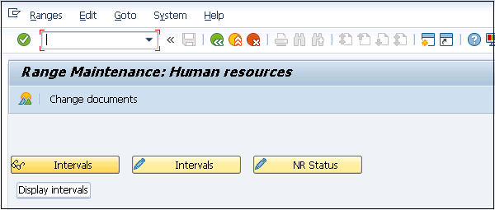

**Step 4** − It will open a new window, **Maintain Intervals: Human resources**. You can check different number ranges for personnel number as shown below −

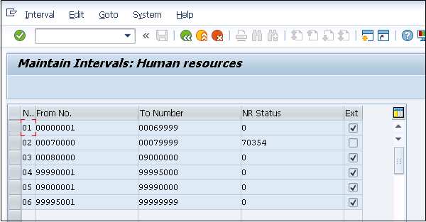

The NR Status indicates the last personnel number assigned/used up for that respective MOLGA. MOLGA Is used to support multi-country human resource management.

SAP HR - Maintaining Relationships

**Example** − A person holding a position in an organization is assigned with cost center. It defines a Person to position relationship and position to Organization unit.

While defining a hierarchical organization structure, it means you are creating a relationship between organization objects. When a person is holding a position in an organization unit, it means there is relationship between position object and organization object.

A relationship can be created in both the ways- top down and bottom approach. These relationships are normally maintained in **HRP001** table. If these relationships are not standard, you may need additional tables.

To maintain relationship, use **T-Code: PP01 or PP03**.

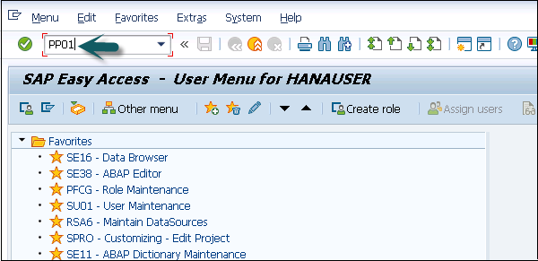

A new window will open with the name **Maintain Object**.

Select the Object type, enter position number, give relationship and click create (F5).

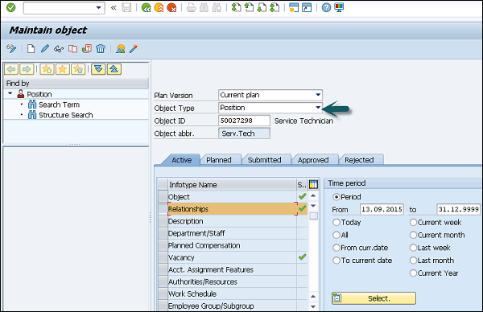

Object Types and Essential Relationships

Go to SPRO → IMG → Personnel Management → Organizational Management → Basic Settings → Data model enhancement → Maintain Object Types → Execute

To create new object type and assigning relationships follow the steps given below.

**Step 1** − Create new object type and assign essential relationships.

**Step 2** − Assign object to the required Infotypes.

**Step 3** − Maintain subtypes.

**Step 4** − Maintain personnel actions.

**Step 5** − Assign number range.

**Step 6** − Maintain object via PP03 or PP01.

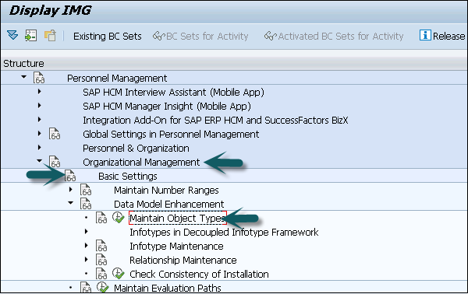

**Step 7** − Go to the **Change View “Object Types”: Overview** window. Click **New Entries** to create a new object type. You can also copy an existing object type.

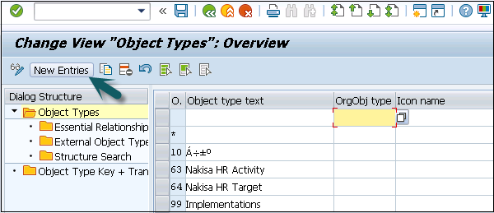

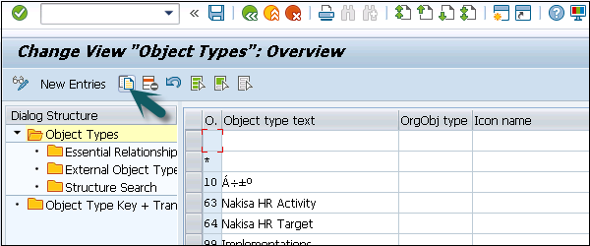

**Step 8** − Enter Object type text, code, etc. When the object is created, assign essential relationships to it by clicking on essential relationships on the left side.

* Assigning a relationship means that once an object is created, the assigned relationships are mandatory to be maintained.
* Maintaining Object types is available in Table: T7780
* Maintaining Essential relationship is available in Table: T7750

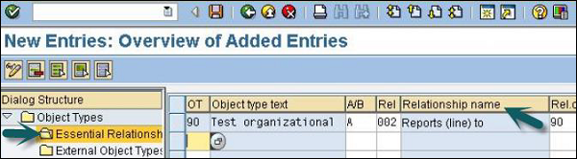

Relationship Maintenance

For maintaining relationship in SAP HR module, go to SPRO → IMG → Personnel Management → Organizational Management → Basic Settings → Data model enhancement → Relationship Maintenance → Maintain Relationships → Execute

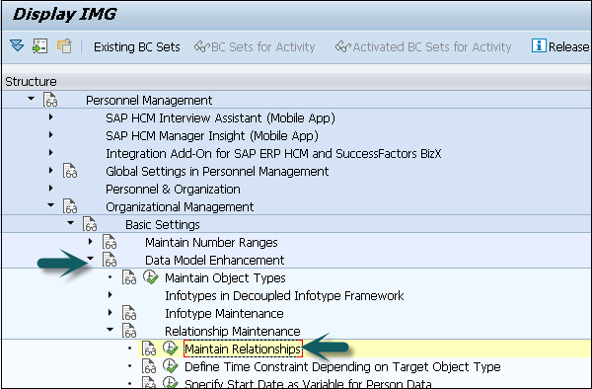

In the left pane, go to **Allowed Relationships**, select the relationship you want to maintain, click **Position**.

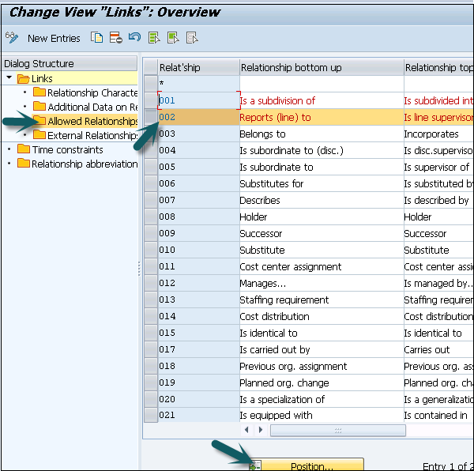

SAP HR - Time Constraints

Time constraints are used to determine how the object type exists and how they will be updated in the HR system.

You can also define time constraints for object types in Organization management to have a suitable system. You need not to keep orphan object types in the system.

* O - O → Time Constraint 1
* O - S → Time Constraint 2
* O - K → Time Constraint 3
* S - O → Time Constraint 4
* S - P → Time Constraint 5

There are three types of time constraints −

* **Time Constraint 1** is mandatory for a record to exist in the HR system and can exist one at any point of time.
* **Time Constraint 2** is not mandatory for a record but only one exists at any point of time.
* **Time Constraint 3** is not mandatory for a record and can have many at any point of time.

Assigning Time Constraints to a relation

**Step 1** − To assign time constraints to a relation, you have to use −

SPRO → IMG → Personnel Management → Organizational Management → Basic Settings → Data model enhancement → Relationship Maintenance → Maintain Relationships → Execute

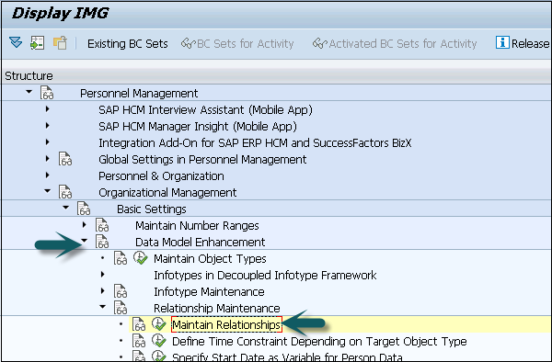

**Step 2** − In the left pane, go to the Time constraint tab as shown in the image given below −

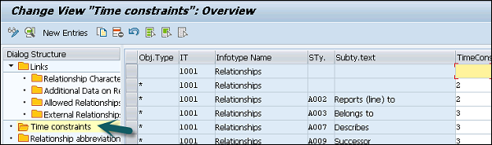

You can assign appropriate time constraints to the given relationship.

Infotypes reactions as per time constraints −

* **Time Constraint 1** − Record must have no gaps, no overlapping. If you select this Time Constraint, there should not be any gaps nor overlapping. This TC is generally used for Infotypes like, 0001, 0008, 0009 etc. where there is only one valid record.
* **Time Constraint 2** − This TC includes those records that can include gaps but there should be no overlapping. If you select this TC, it means that you can have gaps but NO overlapping. Consider an example of the marital status of an employee. The employee has a spouse but a gap can occur in case he is divorced.
* **Time Constraint 3** − This TC includes records that can have gaps and can exist multiple times. For example, Infotype IT0014 can have multiple records in that particular Infotype at the same time with overlapping.

Maintaining Personnel Actions

In SAP HR system, personnel actions are performed for all the Infotypes that require data to be entered in the HR system. Common Infotypes that require a personnel action are hiring a new employee, termination of an employee, etc.

**Step 1** − To perform a Personnel action, use T-Code: **PA 40** or go to SPRO → IMG → Personnel Management → Personnel Administration → Customizing Procedures → Actions.

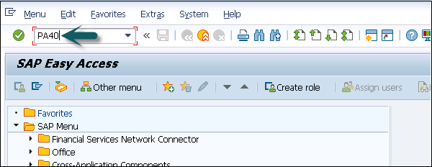

**Step 2** − A new window ‘Personnel Actions’ opens.

The screen consists of the following fields −

* **Personnel No** − This field has an employee’s personnel number. When a new employee is hired, it is generated automatically by the system.
* **Start** − This field shows the start date of the personnel action.
* **Action Type** − In this field, you have to select the action type that needs to be performed.

Example

Let us understand how a new employee is hired in SAP HR system.

**Step 1** − Enter the hiring date as shown below.

**Step 2** − From Action type, select **Hire**.

**Step 3** − Click the **Execute** button given on top.

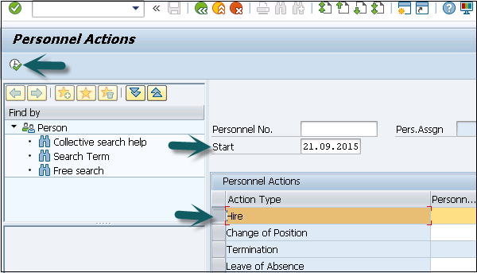

A new window will open. Enter details like Reason for action, Personnel area, Employee group and sub group, etc. and click the Save icon at the top.

SAP HR - Maintaining Infotypes

Components of Infotypes

An Infotype consists of the following components −

Structure

An Infotype contains a set of similar data records in the form of data structure. Infotype contains series of information like first name, last name, date of birth, marital status, etc. When an Infotype is updated in the system, old data is not removed from the system but time is delimited.

Data Entry

You can enter predefined values for Infotype that helps in fetching and maintaining the data in the system. Entries in HR system are checked automatically for accuracy. Default value checks depend on the employee organization assignment.

Time Dependency

When an Infotype is updated in the system, old data is not erased. It is stored in the system for historical evaluation purpose. This allows each Infotype to have multiple records but all the records may vary as per their validity.

Time based reaction of Infotype is defined in the Time constraint field. Infotype 0000 to 0999 are Personnel Administration Infotypes. It is also possible to define permissibility of Infotype for each country, this allows you to restrict Infotype while editing the master data.

Go to SPRO → IMG → Personnel Management → Personnel Administration → Customizing Procedures → Infotypes → Assign Infotypes to Countries

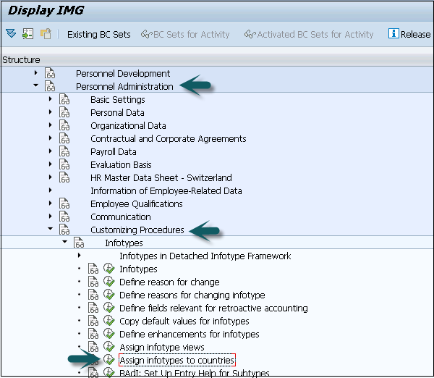

How to Maintain Infotypes?

To maintain Infotype, follow the steps given below −

**Step 1** − Go to SPRO → IMG → Personnel Management → Organizational Management → Basic Setting → Data model enhancement → Infotype Maintenance → Maintain Infotypes → Execute.

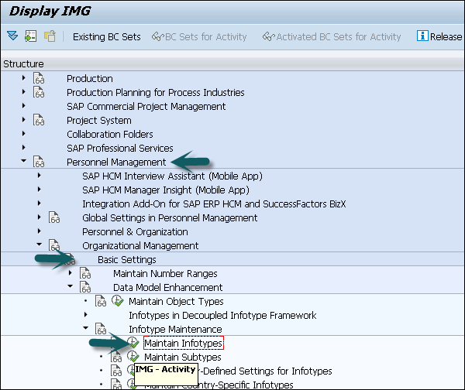

**Step 2** − Select the Infotypes to which the newly created custom object needs to be assigned. Select the Infotype and click the **Infotypes per object type** option.

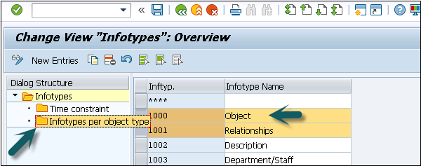

**Step 3** − To assign custom objects to Infotype, click the **New Entries** option. You can uncheck the **No Maintenance** check box such that you can maintain custom objects via Organization Management transactions **PP01**.

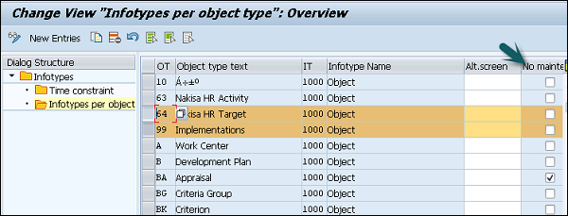

Maintaining Info Subtypes

Info Subtypes are known as sub units of an Infotype. Using subtype, you can easily manage and access the data in HR system and can control the Infotypes. You can easily assign different features to control the data like time constraints to sub types.

You can assign different control features to sub types as per requirement like TC1, TC2, and TC3.

Example

Consider the example of an Infotype Addresses (0006). Following are the subtypes −

* **Subtype 1** − Permanent Residence address
* **Subtype 2** − Temporary address
* **Subtype 3** − Home address

Considering Control feature – Time constraint for this Infotype, you should use TC-3 for Infotype Addresses, as we need to pass multiple values. Permanent Residence address subtype should be Time Constraint -1. Home address can exist once at any one time, hence it is Time Constraint -2.

How to maintain subtypes?

To maintain subtypes −

**Step 1** − Go to SPRO → IMG → Personnel Management → Organizational Management → Data model enhancement → Infotype Maintenance → Maintain subtypes → Execute.

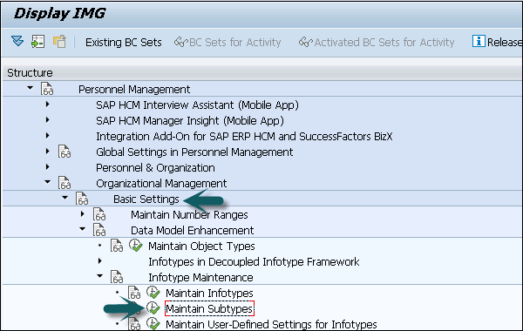

**Step 2** − To maintain subtype, select the subtype in the next window. In the left pane, you have an option to add control feature - Time Constraint.

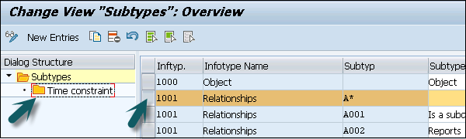

**Step 3** − Double click the Time constraint in the left pane, a new window ‘Change View “Time Constraint”: Overview’ will open.

